Computer Language Coding Concepts

Target Classes in a Diagram
The concept of target classes is explained in the article Target Classes. This article only explains their expression in a diagram.

The target class is found by following the redirections, that lead to a symbol’s class.

When you want to find the class of an object, and the object is actually an object reference, you first need to follow all object reference redirections, to find the target object. When you found the target object, you can find the target class, by following one class redirection.

So to find the target class, you first follow all the object redirections, then one class redirections, then all the object redirections and there it ends.

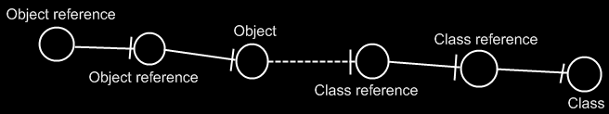

If the class has a class as well, this does not redirect the original object’s class, because the second class is another class object, that the first class is just based on. An object redirection is just a much tighter bond, than a class redirection.

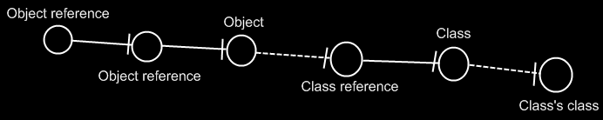

The target class of the first object reference is the symbol Class, not the symbol Class’s class. The same counts for the diagram below.

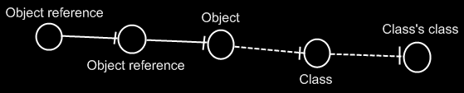

If you wonder what could be that different between Class and Class’s class: they could differ in default values. The main point is: finding the target class is about finding the class object.

See also: Target Classes

Author & Copyright: Jan-Joost van Zon Date: May 29, 2008 – May 5, 2010 Location: Oosterhout, The Netherlands Status: Finished

